STANDARD OPERATING PROCEDURE

Document Control
Document No. | SOP-TV-001
Version | 1.0
Department | Migration Services
Effective Date | ________________
Approved By | ________________

Purpose
This Standard Operating Procedure (SOP) outlines the process for assessing, preparing, lodging, and monitoring Australian Visitor Visa (Subclass 600) applications. It ensures all applications are processed consistently, accurately, and in accordance with the requirements of the Australian Department of Home Affairs and relevant migration legislation.

Scope
This SOP applies to all consultants, migration agents, and processing staff involved in the preparation and lodgment of Visitor Visa (Subclass 600) applications for both offshore and onshore clients.
The procedure covers:
- Client enquiry
- Initial consultation
- Eligibility assessment
- Document collection
- Application preparation
- Visa lodgement
- Post-lodgement monitoring
- Requests for Further Information
- Visa outcome
- Client communication
- Record management

Roles and Responsibilities

Consultant
The Consultant is responsible for:
- Conducting the initial client consultation.
- Determining the client's purpose of travel, travel history, financial capacity, and ties to their home country.
- Completing the Client Inquiry Form.
- Registering the client in the Client Engagement Log.
- Creating the client's digital folder.
- Collecting all required supporting documents.
- Following up outstanding documents.
- Explaining the visa process, estimated processing times, and required documentation to the client.
- Endorsing the case to the Migration Agent for eligibility assessment.
- Keeping the client updated throughout the application process.
- Assisting with Requests for Further Information (RFI), if required.

Migration Agent
The Migration Agent is responsible for:
- Reviewing the client's circumstances and travel purpose.
- Assessing whether the client meets the Visitor Visa requirements.
- Identifying any potential risks that may affect the application.
- Providing migration advice where necessary.
- Reviewing the completed application before lodgement.
- Endorsing the application to the processing officer for lodgement.
- Advising on responses to Requests for Further Information (RFI) or Notices of Intention to Consider Refusal (NOICC), where applicable.
- Reviewing all supporting documents for completeness and accuracy.
- Preparing the Visitor Visa application.
- Uploading supporting documents to ImmiAccount.
- Lodging the application.
- Monitoring the application after submission.
- Notifying the Consultant of any updates or requests from the Department.

Tools and Systems
The following systems shall be used throughout the Visitor Visa application process:
- Client Engagement Log
- Client Inquiry Form
- Tourist Visa Document Checklist
- Internal Case Management System
- Client Digital Filing System
- Google Drive / Internal Document Storage
- Email
- ImmiAccount

Document Management

Every client must be registered in the Client Engagement Log to generate a Unique Client Code

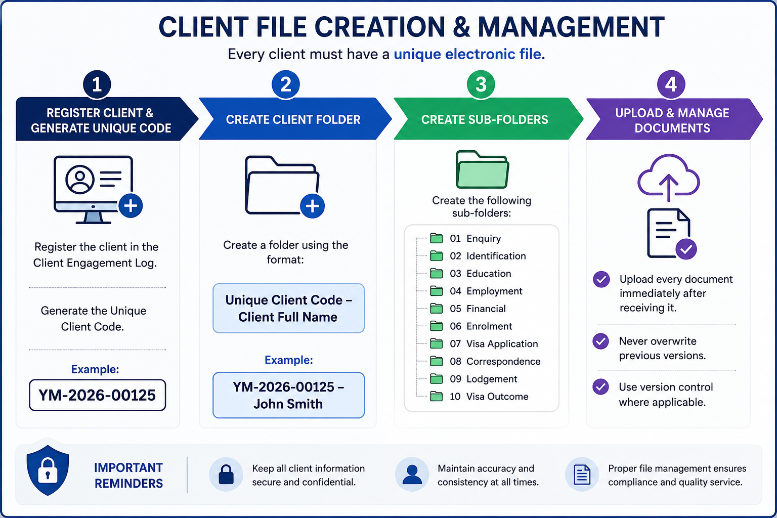

Step | Process | Procedure
1 | Register Client | Register the client in the Client Engagement Log and generate a Unique Client Code.  Example: YM-2026-00125
2 | Create Client Folder | Create a client folder using the following naming convention:  Unique Client Code – Client Full Name  Example: YM-2026-00125 – John Smith
3 | Create Sub-Folders | Create the following folders within the client's main folder:  01. Enquiry  02. Identification  03. Education  04. Employment  05. Financial  06. Enrolment  07. Visa Application  08. Correspondence  09. Lodgement  10. Visa Outcome
4 | Upload & Maintain Documents | Upload all client documents immediately upon receipt.  • Do not overwrite previous versions.  • Apply version control where necessary.  • Ensure all documents are saved in the correct sub-folder.

- TOURSIT VISA PROCESSING PROCEDURE

Step | Process | Responsibility | Procedure
1 | Client Enquiry | Consultant | Receive the client's enquiry and schedule an initial consultation.
2 | Initial Consultation | Consultant | Conduct a consultation to assess the client's purpose of travel, financial capacity, employment or business status, travel history, family circumstances, and ties to their home country. Explain the Visitor Visa application process, estimated processing times, required documents, and professional fees.
3 | Complete Client Inquiry Form | Consultant | Complete the Client Inquiry Form and register the client in the Client Engagement Log to generate a Unique Client Code.
4 | Document Collection | Consultant | Provide the client with the required document checklist and collect all supporting documents necessary for the Visitor Visa application.
5 | Eligibility Assessment | Migration Agent | Review the client's information and supporting documents to determine eligibility for the appropriate Visitor Visa stream and identify any potential risks or additional requirements.
6 | Draft Application | Consultant | Prepare the draft Visitor Visa application and organize all supporting documents.
7 | Client Confirmation | Consultant | Send the completed draft application to the client for review and confirmation. Obtain written confirmation that all information provided is true, complete, and accurate before proceeding.
8 | Migration Agent Review | Consultant / Migration Agent | Once the client has confirmed the draft, notify the Migration Agent that the application is ready for final review. The Migration Agent will review the application, supporting documents, and overall submission to ensure compliance with Department of Home Affairs requirements.
9 | Visa Lodgment | Migration Agent | Lodge the Visitor Visa application through ImmiAccount after confirming that all information and documents are complete and accurate.
10 | Post-Lodgment Monitoring | Consultant | Monitor the application through ImmiAccount and keep the client informed of any updates, including requests for further information, health examinations, biometrics, or visa outcomes.
11 | Requests for Further Information (if applicable) | Consultant | Collect any additional documents requested by the Department of Home Affairs and submit them after review by the Migration Agent, where required.
12 | Visa Outcome | Consultant | Notify the client of the visa decision. If the visa is granted, explain the visa conditions. If the application is refused, arrange a consultation with the Migration Agent to discuss the decision and available options.
13 | File Completion | Consultant | Save all correspondence, application documents, and the visa outcome in the client's digital file, update the Client Engagement Log, and close the matter.
- Quality Control Checklist
Before the Visitor Visa application is lodged, the following checks must be completed:
Quality Control Item | ✓
Client Inquiry Form has been completed. | ☐
Client has been registered in the Client Engagement Log and a Unique Client Code has been generated. | ☐
Client identity has been verified using a valid passport. | ☐
The correct Visitor Visa (Subclass 600) stream has been identified. | ☐
All required supporting documents have been received. | ☐
Financial documents have been reviewed for adequacy and consistency. | ☐
Evidence of employment, business ownership, study, or other commitments has been provided (where applicable). | ☐
Evidence of family, economic, or social ties to the home country has been provided. | ☐
Invitation letter and sponsor documents have been obtained (if applicable). | ☐
Travel itinerary and purpose of visit have been clearly documented. | ☐
All supporting documents are clear, complete, and legible. | ☐
Any non-English documents have been translated by an accredited translator (if applicable). | ☐
The draft visa application has been prepared by the Consultant. | ☐
The client has reviewed and confirmed that all information in the draft application is true and correct. | ☐
The Migration Agent has completed the final review of the application and supporting documents. | ☐
Visa application charges have been confirmed with the client prior to lodgment. | ☐
The application has been lodged through ImmiAccount. | ☐
Lodgment confirmation has been saved in the client's digital file. | ☐
The client has been notified that the application has been lodged. | ☐
The Client Engagement Log and client file have been updated with the current application status. | ☐

8. Compliance and Disclosure
Yale Migration is committed to maintaining the highest standards of professionalism, ethical conduct and compliance with Australian migration legislation.
All staff involved in Graduate Visa applications must comply with the following requirements:

Legislative Compliance
- Comply with all applicable Australian migration legislation, regulations and policy requirements.
- Follow all requirements of the Department of Home Affairs when preparing and lodging visa applications.
- Ensure that all information provided in a visa application is accurate, truthful and supported by appropriate evidence.

Professional Responsibilities
- Only a Registered Migration Agent may provide migration advice or make legal representations regarding visa matters.
- Consultants and administrative staff must not provide migration advice unless authorised to do so.
- Any complex migration issues must be referred to the Registered Migration Agent.

Client Confidentiality
- Protect all client information in accordance with Australian privacy requirements and the agency's privacy policy.
- Client information must only be accessed by authorized staff for legitimate business purposes.
- Client documents must be stored securely within the agency's approved document management system.

Accuracy and Record Management
- Maintain complete, accurate and up-to-date client records always.
- Record all client communications, advice provided, and documents received or submitted.
- Ensure all electronic files follow the agency's document naming and filing procedures.

Fee Disclosure
Before commencing any work, the client must receive clear written information regarding:
- Professional service fees.
- Government Visa Application Charges (VAC).

Client Acknowledgement
Before visa lodgment, the client must acknowledge that:
- All information provided is true, complete and accurate.
- They have reviewed and approved the final visa application.
- They understand their obligations as a Student Visa holder.
- They understand that providing false or misleading information may result in visa refusal or cancellation.

Visa Outcome Disclaimer
Yale Migration will prepare and manage every application with due skill, care and diligence. However, the approval or refusal of any visa application is solely at the discretion of the Department of Home Affairs.
Neither Yale Migration nor the Registered Migration Agent can guarantee the grant of a visa, as each application is assessed on its individual merits and in accordance with Australian migration legislation and policy.

